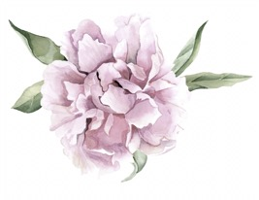
AG

Darcy Mantel
Feature Pitch- Online Magazine

Subject: 20-year-old local business running strong!
To: Vida Schuman, Publisher and Founder of Oklahoma Magazine, mail@okmag.com
http://www.okmag.com/contact/

Dear Ms. Schuman,

My name is Darcy and I am a student at the University of Oklahoma in the Public Relations program. I am writing to you to tell you about an incredible brand that I am working with that I feel should be featured in your magazine.
Antique Garden is a locally owned business right off of campus here in Norman. They are a home and clothing boutique that is known for having the best Free People section in Oklahoma and they just celebrated their 20-year anniversary. My goal for them is to spread their name beyond just Norman, and I think that they are more than well-deserving of being featured in your magazine.
I would love to hear back from you about this and hear your thoughts. Can you do this Friday? You can call or text me at 214-649-0091 or e-mail me back here.

I appreciate your time.
Sincerely,
Darcy Mantel
Trend Pitch

Subject: Best Free People Section in Oklahoma!
To: Nicole Crain, Fashion Editor at Splurge! Oklahoma Magazine, nicole@splurgeokc.com
http://splurgeokc.com/about/

Dear Ms. Crain,

My name is Darcy and I am a student at the University of Oklahoma in the Public Relations program. I am writing to you to tell you about an incredible brand that I am working with that I feel should be featured in your magazine.
Antique Garden is a locally owned business here in Norman. They carry clothing, shoes, accessories, home décor, furniture, and more. Antique Garden has been recognized for having one of the best Free People selections in Oklahoma. They are very successful and I think they are deserving of a feature in your magazine.
I would love to hear back from you about this and hear your thoughts. Can you do this Friday? You can call or text me at 214-649-0091 or e-mail me back here.

I appreciate your time.
Sincerely,
Darcy Mantel

