AG

Darcy Mantel

Client Photos

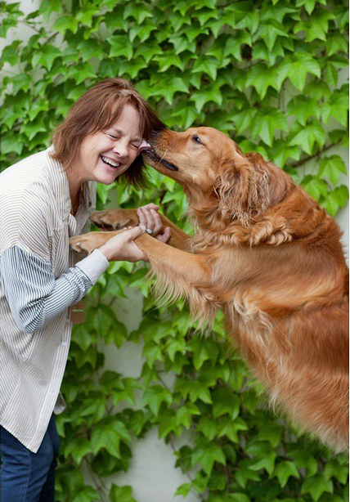
Photo #1: The first picture I am going to use will be of the main store owner, Barbara Fite. This picture is essential because it creates a personal relationship with the store’s customers. Barbara is well-known in the Norman area because of her store, so it would be great publicity to include that picture of her. For a caption, I would say, “Barbara Fite, owner of locally owned business Antique Garden.”

Photo #2: The second picture will be of Antique Garden’s co-owner, Mariah Hope. Mariah is Barbara’s daughter, which makes another personal relationship. Having a mother/daughter owned store is very emotionally appealing, so I think it is important to include her in one of the pictures. For a caption, I would say, “Mariah Hope, daughter to Barbara and co-owner of locally owned Antique Garden.”

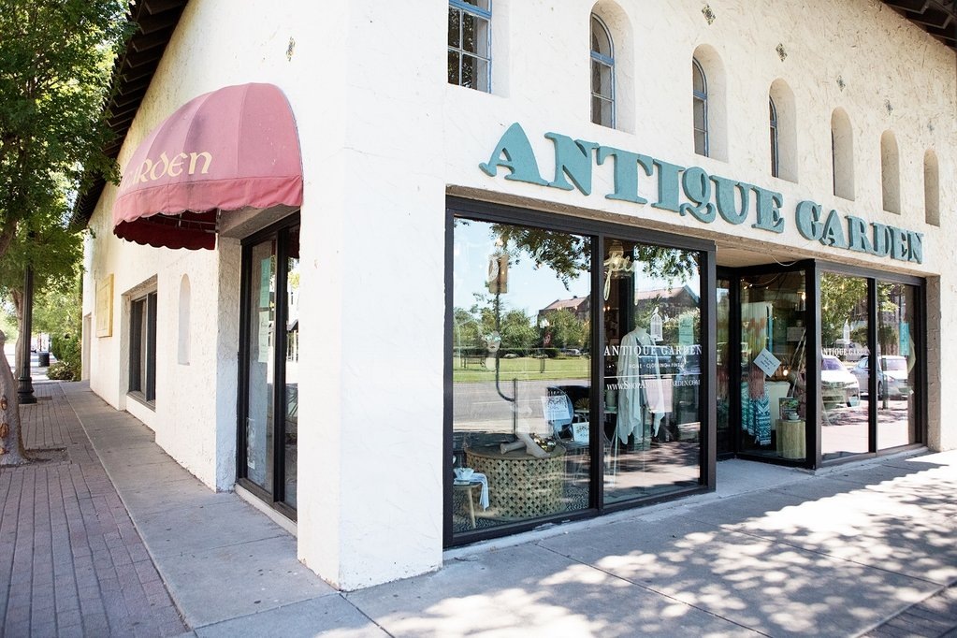
Photo #3: The third photo will be a shot of the store from the outside. In my head, it is a wide-shot image. I think it is definitely important to include this as one of the photos because the store’s being on the corner makes it very memorable. For a caption, I would say, “Antique Garden is a locally owned business specializing in antiques and clothing. It has been around for 20 years and is owned by Barbara Fit and Mariah Hope, a mother/daughter duo.”
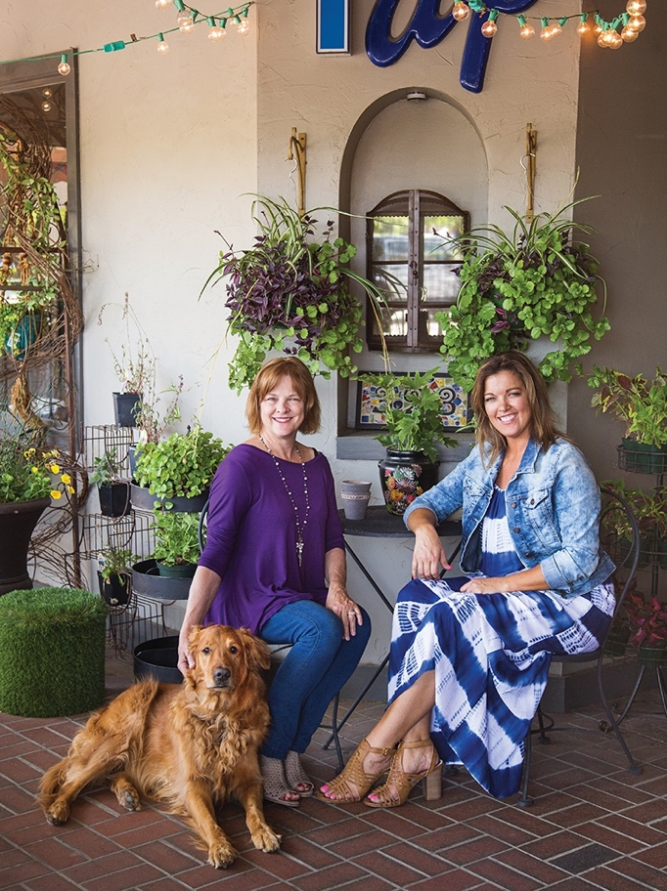
Photo #4: For the last picture, I will do a picture of Barbara and Mariah, the two store owners. I think it is important to include a picture of the mother/daughter duo because it gives a personal touch to the store, as well as charm and comfort. For a caption, I would say something like, “Check out co-owners Barb and Mariah, who also happen to be mother and daughter! Their passion for Antique Garden shines on their faces. Leo the Golden Retriever shop dog says come say hello!”

