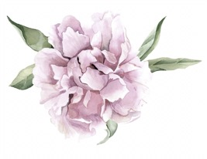
AG

Darcy Mantel

Fact Sheet

1.Antique Garden has been open for 20 years, since 1997.
2.Antique Garden is featured on 5 local websites.
3.Antique Garden only has one store open.
4.Antique Garden has a successful online store as well as Instagram and Facebook.
5.The store is co-owned by a mother daughter duo.
6.The store offers many discounts, one being student discounts every Monday.
7.Antique Garden has hundreds of different items from clothing, to home accessories, to lighting, to furniture.
8.Antique Garden is the oldest standing boutique on Campus Corner.
9.Antique Garden is recognized on the National Retail Federation website as a small business spotlight.
10.After 20 years of success, Barbara Fite, owner of Antique Garden, sold her store to a new owner in 2017.

