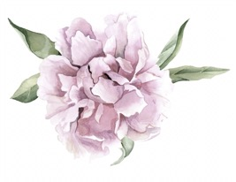
AG

Darcy Mantel
NEWS RELEASE

Antique Garden Celebrates their 20th Birthday
Local Home and Clothing Boutique Celebrate their 20- year success

Norman, OK: Antique Garden, a locally owned business run by a mother/daughter duo, turned 20 this June. After opening their business in 1997, Barbara Fite and Mariah Pinkerton were delightfully surprised with the success their store earned. “Most local business only last for a short amount of time, if they last at all”, said owner Barbara Fite. Their party took place on May 20th at the store on Campus Corner.

To celebrate the store’s birthday, the co-owners threw a 20th Birthday Bash, where they stayed open late, served drinks and snacks, and had crazy discounts. “We really just wanted to thank our customers. We wouldn’t be successful if it weren’t for them so we wanted to give back with our party”, said Mariah Pinkerton, Barbara’s daughter and co-owner.

To get the word out about their birthday celebration, the Antique Garden team started posting about the party a few weeks in advance. They posted mostly to Instagram, but they made an official “event” for the party on Facebook so that they could invite all of their friends. After listening to Barbara and Mariah, it was undeniable that they had a lot of love and passion for their store.

To contact Antique Garden:
Call +1 405-321-1772 or go to www.shopantiquegarden.com
To interview with Antique Garden:
Store Hours include
Monday-Friday 11 a.m.-6 p.m.
Saturday-Sunday 12 p.m.-5 p.m.

